Miguel Mojica, Miguel Eljuri, Brian Valera, Monico Lara Jr., Juan Garcia
CS 3301, Yuchou Chang
Project Report
11/31/2018
Team Name: WhiteBoard
Our team used a Democratic Team model, while also employing the advantages of a Chief Programmer Team for developing important components that some members were more familiarized with.
Project Development Overview
We started the project by designing the basic functionality of the software and developing a Use-Case Document and Diagram, then we drafted a rough UML Diagram. We then began researching software that would facilitate the implementation of the functionalities and decided to use VisualStudio for C++ programming, SQLite for developing databases and QT for GUI development.
The first complication came when we found out QT would require us to learn a new unfamiliar program within the span of one semester and develop the code using primarily this program. Problems with instability across different computers and concerns with implementing SQL databases prompted us to look for easier alternatives and decided to switch to VisualBasic.
Due to the nature of VisualBasic, it wasn’t possible to integrate any SQL code until we fully developed the basic components of the GUI. This caused a few members to stall while the GUI developers finished their assigned tasks. Once the GUI was completed, the next complication is that the only person who could figure out how to integrate SQL databases is the person in charge of creating databases. After more research and development, we were able to successfully integrate the software and all of our efforts were concentrated in testing and populating the databases while slowly adding the required functionality.

Appendix: Diagrams

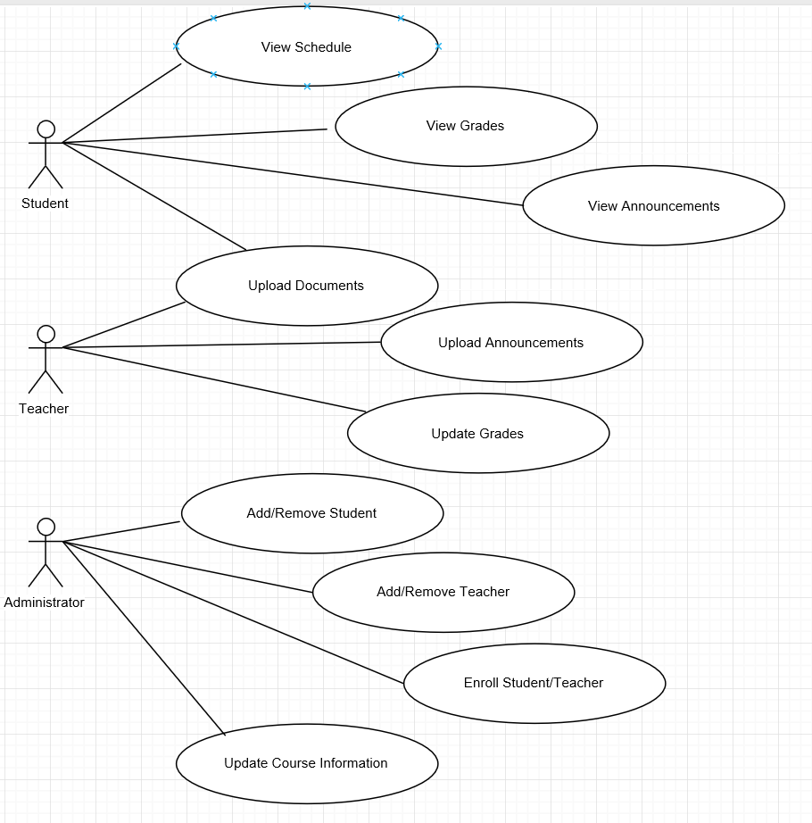
Initial Use-Case Diagram

Initial Use-Case Document

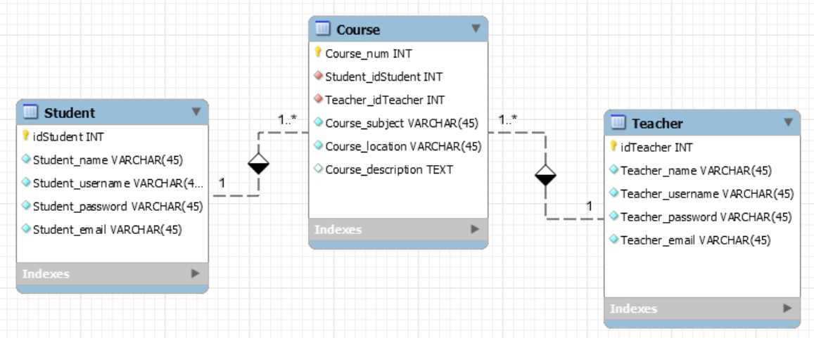
Initial ER Diagram

Initial UML Diagram

Current Use Case Diagram

SPMP Chart

CRC Cards

